ta

A Peek at Our Week

Week of August 1-5, 2016



**Ah-“Mason” Happenings in the Fifth Grade**

Week of November 6-November 10



Follow our school on Twitter @HillCityHawks.

Dear Parents,

This week in your child’s Friday folder you will be receiving important information about our upcoming Dollar Days. We will be using these days as a means of raising funds for 5th grade activities throughout the year and would greatly appreciate your help and support.

In addition, please remember that Tuesday, November 7th is an inservice day. On Friday, November 10th we will be hosting our annual Veteran’s Day Lunch, and we would love to show you our appreciation and gratitude to the important veterans in your child’s life. Please extend this invitation to our local Heroes.

Lastly, if you are interested in volunteering for our Thanksgiving lunch please let your child’s homeroom teacher know.

Thank you,

Fifth Grade Teachers

 We



Things to Know

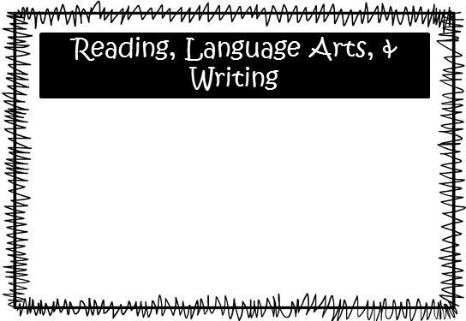.the

Patterson’s Classes: We will be wrapping up out novel, *Bud, Not Buddy*, and will begin working on a culminating performance task in which students will write an editorial review of the novel. We will not have a vocabulary test next week. We will continue to work on constructed responses and extended responses on the WriteScore platform.

Wilds’ Classes: We will be finishing *Bud, Not Buddy*. In writing, we will continue to work on informational writing.

Science: We will continue our studies of landforms and the technology used to investigate and gather data to interpret changes in the Earth’s surface. Lo will test on Tuesday, November 14th.

Social Studies: We will be beginning our new unit on World War I. We will test over this material on Thursday, November 16th.

**Smith:** We will finish up adding and subtracting with decimals. We will start multiplying and dividing with decimals.

**McEntire’s Homeroom:** We are moving into multiplying decimals, as well as, reviewing previous skills.

**Wilds’ Homeroom:** We are moving into dividing decimals, as well as, reviewing previous skills.

Please consider donating Vienna sausages for Snack Packs!

Upcoming Events:

* November 7th—Inservice Day, no school for students
* November 10th—Veteran’s Day Lunch and PTO Santa Night
* November 16th—Last Day for Purchasing Turkey Feathers
* November 17th—Thanksgiving Lunch, $4.00 per visitor
* November 20th-24th—Thanksgiving Holidays

Email Addresses:

[Amandalo@pickenscountyschools.org](mailto:Amandalo@pickenscountyschools.org)

[Ashleypatterson@pickenscountyschools.org](mailto:Ashleypatterson@pickenscountyschools.org)

Brandimcentire@pickenscountyschools.org

[Carolsmith@pickenscountyschools.org](mailto:Carolsmith@pickenscountyschools.org)

Jenniferwilds@pickenscountyschools.org

Math