ta

A Peek at Our Week

Week of August 1-5, 2016



**Ah-“Mason” Happenings in the Fifth Grade**

Week of October 9-13



Follow our school on Twitter @HillCityHawks.

Dear Parents,

For those of you who were able to attend our Parent Academy on Monday, we wanted to thank you again. If you were unable to attend, you will find information regarding your child’s reading performance and resources to use at home in your child’s Friday folder. Should you have any questions or concerns, please do not hesitate to let us know.

October is quite a busy month! Please notice that we will have our Title I Meeting on Monday, October 9th at 6:00 PM. Also, fourth and fifth graders will have a 50s dance on Wednesday, October 18th. Permission slips will be coming home and MUST be returned.

Thank you,

Fifth Grade Teachers

 We

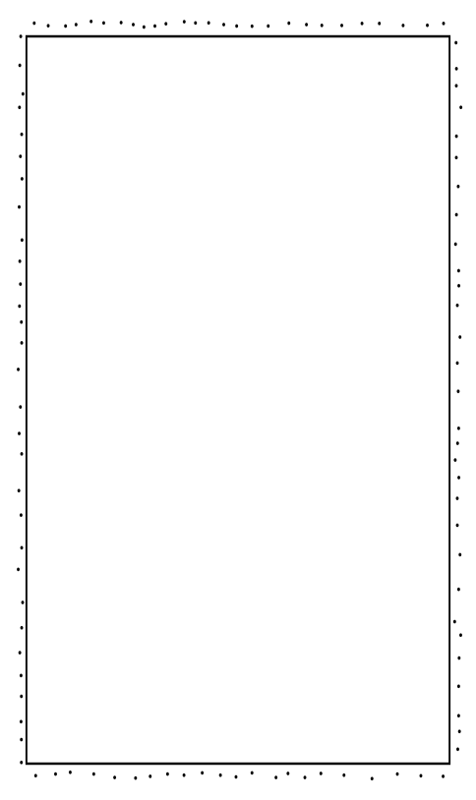

Things to Know

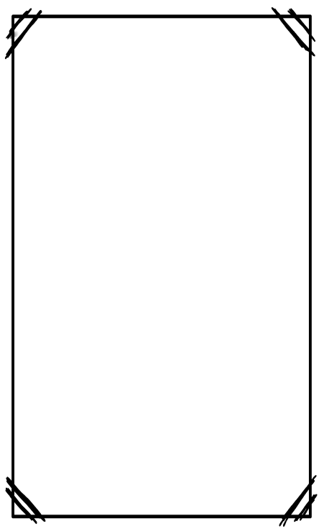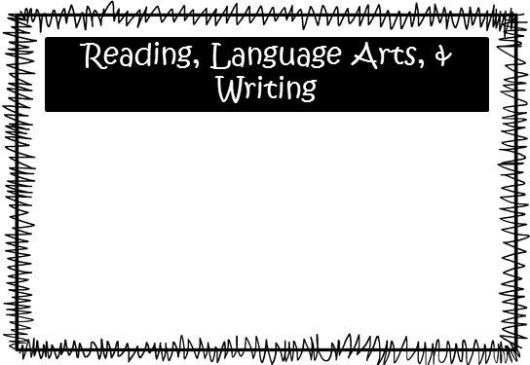

Science: **Lo:** We will explore how the presence or absence of vegetation can impact weathering, erosion, and deposition.

**McEntire:** We are continuing our studies of landforms.

Social Studies: We will begin to explore the turn of the century with the significance of the Great Western and Chisholm cattle trails.

**Smith:** We are working with place value going up through billions and going down as small as thousandths. We will begin changing decimals to fractions and vice versa and will also start adding and subtracting numbers with decimals.

**McEntire’s Homeroom:** We are working on dividing by one digit divisors.

**Wilds’ Homeroom:** We will finish up working on dividing by two digit divisors and will be moving into decimals.

Please consider donating Vienna sausages for Snack Packs!

Upcoming Events:

* October 9th, Title I Meeting, 6:00 PM
* October 18th, 50’s Dance for 4th and 5th Grade and 50’s Dress Up Day
* October 30th, Book Fair begins
* October 31st, Donuts for “Dudes” and Dress Up Day

Email Addresses:

[Amandalo@pickenscountyschools.org](mailto:Amandalo@pickenscountyschools.org)

[Ashleypatterson@pickenscountyschools.org](mailto:Ashleypatterson@pickenscountyschools.org)

Brandimcentire@pickenscountyschools.org

[Carolsmith@pickenscountyschools.org](mailto:Carolsmith@pickenscountyschools.org)

Jenniferwilds@pickenscountyschools.org

We will be beginning our new novel, *Bud, Not Buddy*. Students will experience the Great Depression as the novel follows a young, orphan boy’s journey to find his father. *Bud, Not Buddy* will serve as a wonderful springboard for discussions about the Great Depression and will provide students a preview of the content before beginning their studies in social studies. We will have a vocabulary test on Friday, October 13th. In writing, we will continue to practice writing compound and complex sentences, and students will respond to non-fiction constructed responses.

Math